**Involve Selection Ltd / Vocate Training Internal Quality Assurance Policy & Strategy**

**Apprenticeships & Functional Skills**

**Introduction**

Involve Selection Ltd has a robust approach towards quality assurance. Our aim is to continuously check, review and revise our processes and to ensure that we always provide the highest standards in delivery and assessment.

**Overview**

Internal Quality Assurance (IQA) forms one part of the Company’s Quality Assurance Process and focuses on our responsibilities to ensure:

* An appropriate design of a programme to meet all qualification or unit specifications and rules of combination, as well as meeting the criteria of apprenticeship standard
* Effective delivery that meets learner expectations and agreed learner journey
* The accuracy and consistency of assessment decisions between assessors
* Assessors are consistent in their interpretation of qualification or national occupational standards
* Maintenance of documentation audit trail to enable certification and distribution to learners
* Monitoring, review and evaluation for continuous improvement

**Assessors and Internal Quality Assurers**

Assessors are selected for their relevant occupational competence. They must hold the Level 3 Certificate in Assessing Vocational Achievement (CAVA) or A1 or D32/33 or be working towards CAVA. They must be current practitioners and be able to demonstrate a clear understanding of the role of assessor. Where a new assessor is recruited, they are provided with a clear action plan for achieving the level 3 units within a maximum of 18 months. During this time, they are coached and supported by the Internal Quality Assurer (IQA). The IQA will give sufficient support and have relevant technical/occupational familiarity for the area of verification and be fully conversant with the units. The IQA will hold the Training, Assessment, Quality, Assurance (TAQA) or V1 or D34.

**Standardisation Meetings**

It is the responsibility of the Lead IQA to hold standardisation meetings. These will be organised periodically, but there will be a minimum of four standardisation meetings per year. Items for discussion will include (but not limited to) the following:

* IQA strategy
* IQA tracking
* IQA actions
* Standardisation / best practice
* Actions from EQA visits
* Feedback from inspections or self-assessment reports
* Changes in procedures, paperwork, funding partner processes
* Development sessions
* Key actions will be recorded, resolved and retained for future review, as required. Actions will also inform the Quality Improvement Plan (QIP).

**IQA strategy**

In all cases the assessment strategy for the qualification must be consulted for specific requirements. It is good practice to follow the ‘CAMERA’ model as well as ‘VACS’ model:

|  |  |  |  |  |  |  |  |  |  |  |  |  |  |  |  |
| --- | --- | --- | --- | --- | --- | --- | --- | --- | --- | --- | --- | --- | --- | --- | --- |
| |  |  | | --- | --- | | Factors | Sampling must cover/consider | | Candidates/Learners | Ethnicity, age, gender, whether candidates are employed full or part time and any special arrangements | | Assessors | Experience (new assessors are higher risk), feedback from EQA visits, qualifications, workload, occupational experience | | Methods of assessment | Questioning, observation, testimony, RPL, use of simulation, product evidence, assignments, projects and tests | | Evidence types | Written confirmation that evidence is valid, authentic, current, sufficient plus a focus on any special requirements and identified problem units | | Records | All documentation relating to assessments and assessment feedback to learners | | Assessment locations | Different assessment locations | |  |

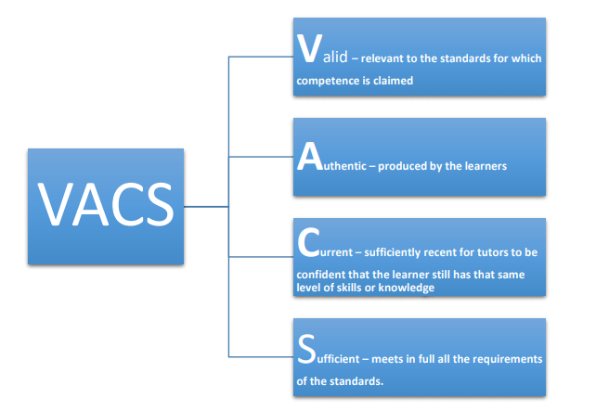

In all cases the Sampling Strategy will reflect the risk analysis of the qualification, assessor and learners. The IQA verification process will sample across all activity and delivery sites. Sampling will include the type of activity undertaken, evidence, knowledge and feedback. This will be an integral part of the IQA role and form part of the standardisation process. As in the table above, the choice of focus could depend upon many factors including identified issues in assessment of the unit, feedback from EQA and concerns about standardisation.

The IQA will conduct four assessments per year and along with sampling learner portfolios, this can include assessor observations, learner interviews and quality checks on reviews, as well as checking progress over time. The sampling records will be completed by the IQA and uploaded to show live sampling through all delivery sites, qualification, learners and assessors for monitoring purposes.

The IQA will be responsible for conducting candidate interviews across each programme. This is to provide a holistic approach towards maintaining high standards and provide feedback to assessors as appropriate. The percentage of interviews will be flexible and be supportive of the assessment process and not impede the learner unnecessarily.

**IQA Planning**

IQAs will complete Involve Selection Ltd sampling plan (s) at the start of each qualification outlining what will be monitored. This plan will be held in an electronic format by IQAs. It will be consistently updated to reflect samples and changes in the ‘RAG’ rating for the delivery staff.

**Internal quality assurance sampling**

Throughout the Learner journey, IQAs will record and report on all sampling and monitoring undertaken in sufficient detail to justify their decisions on the ‘RAG’ rating applied to the tutors on the Sampling plan

**Sampling strategy**

All tutors will be included in the sample plan and be given a ‘RAG’ rating, in conjunction with CAMERA .

The information found by carrying out a sample will then form the basis of the RAG rating and will inform how they will sample, support and develop tutors to improve their practice.

**Any tutor working across Apprenticeships, or Functional Skills Delivery will receive a separate risk rating and support per qualification type.**

**Rag Rating Strategy for all Tutors**:

Red – High Risk tutor High risk status will be applied to any tutor where an OTLA has been graded as a 3 or 4 (Ofsted standardised rating). Any new tutors, existing tutors delivering new courses or tutors without current CPD will also be high risk. An action plan will be produced and the tutor will be subject to 100% sampling until progress in the areas requiring improvement has taken place. The IQA will sample the tutor through all of their caseload and using the sampling plan, will ensure that every assessment method and every unit has been sampled. Monthly observations of the tutor will be conducted.

Green – Low Risk tutor Low risk status will be applied to any tutor where a tutor has been graded 1 or 2 (Ofsted standardised rating). An action plan will be produced and the tutor will be subject to a minimum of 30% sampling covering all units and assessments. IQA will check that unit selection and delivery documentation is to the required standard. One observation of tutor will be conducted both every 6 months.

**Internal Quality Assurance for all courses**:

The IQA process includes initial Involve Selection Ltd approval to deliver apprenticeship standards and or functional skills and procedures for ensuring quality standards are maintained.

The internal quality assurance system contains:

1. Involve Selection Ltd IQA policies

2. Sample planning based on the ‘CAMERA’ principles

3. Formative and summative sampling of learners work to be conducted throughout the learning

programme

4. Effective communication and feedback to learners (including Pastoral Support), employers,

managers and QIPs

5. Full monitoring and recording of the learning and learner journey

6. Observations of tutors followed by interventions and support

7. Quarterly standardisation activities based on feedback from observations, EQA reports, awarding

bodies updates, learning walks and interventions

8. Administration – thorough completion and compilation of all documentation

9. Effective standardised recording of evidence; i.e. minutes of all meetings, observations,

interventions, support and dissemination to enable a whole organisational approach to continuous

improvement.

**Formative sampling**:

IQAs will assess and evaluate the impact the tutor has on the learner’s progress and achievement throughout all stages of the learner’s journey. This will include initial assessment, induction, teaching, learning and assessment including target setting and assessment planning and preparation.

Formative sampling will include checking progress review documents for SMART targets as part of Individual Learning Plans and Learner interviews, this will include actions, follow up and impact on learner progress and achievement. Ensure that all is recorded on the sampling plan spreadsheet.

**Summative sampling**:

Summative sampling will review the completed learner journey and assessment judgements taken in their entirety. IQAs will follow an audit trail which clearly demonstrates that tutors have covered all the requirements and checked that all work presented, whatever its format, meets the rules of evidence

**Systems**

All IQA decisions will be captured on E-LMS to be completed as the IQA activity takes place. The summary feedback from the systems will be discussed at each standardisation meeting.