SCENARIO ONE
Scenario Summary heading should be bold
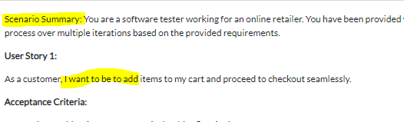
Why twice and for word processor please specify that tool is down below to be used.

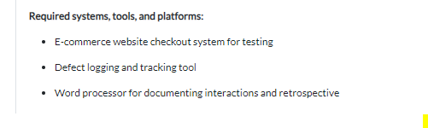
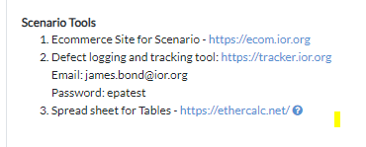

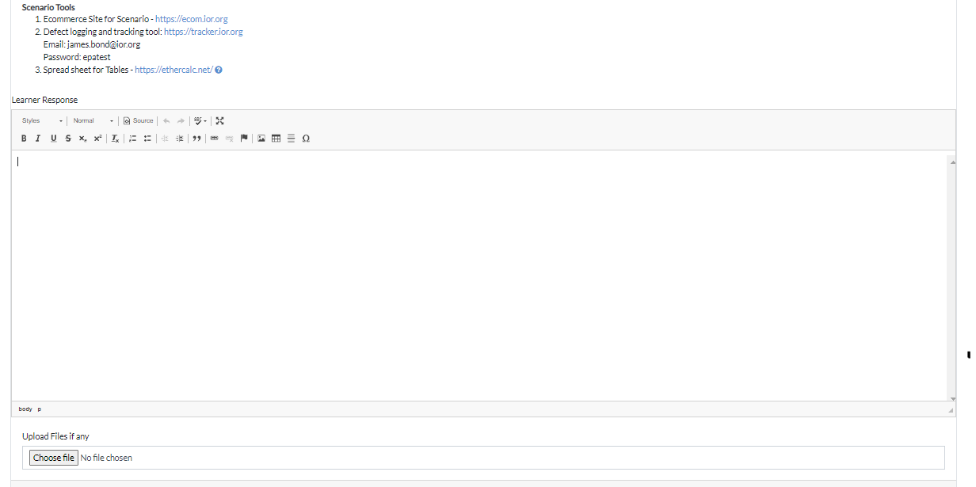

User Story 1:
As a customer, I want to be to add items to my cart and proceed to checkout seamlessly.
Acceptance Criteria:
- When I add an item to my cart, it should reflect in the cart summary.
  - It is reflecting
- I should be able to view and edit the items in my cart before proceeding to checkout.
  - Can be done
- The checkout button should lead me to a secure and user-friendly payment process.
  - No secure and user-friendly checkout payment – added option to add card details and now order can be completed
  - I had my info filled before now when I go back City is inputted as Other although I inputted Manchester - fixed
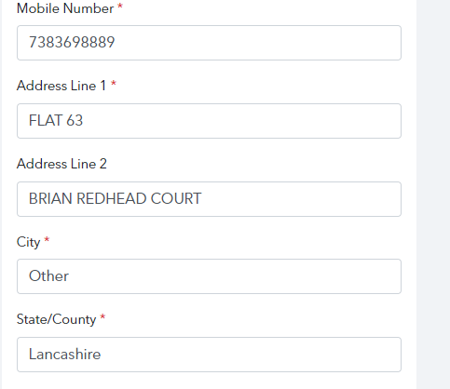
  - Mobile number validation fixed – now need to to enter 11 digits
  - When I remove city, state goes to Uttar Pradesh also when I filled in my address first time Uttar Pradesh was selected as state fixed
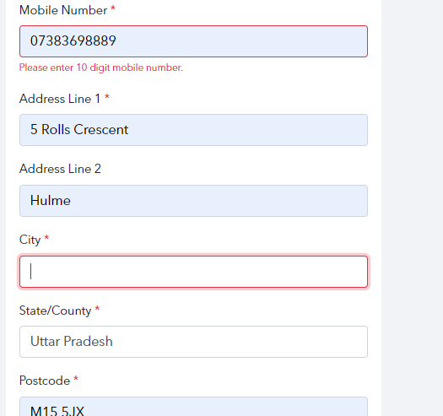
  - When I Click Proceed to payment it takes me to blank page – Payment gateway not added – let me see any test payment gateway
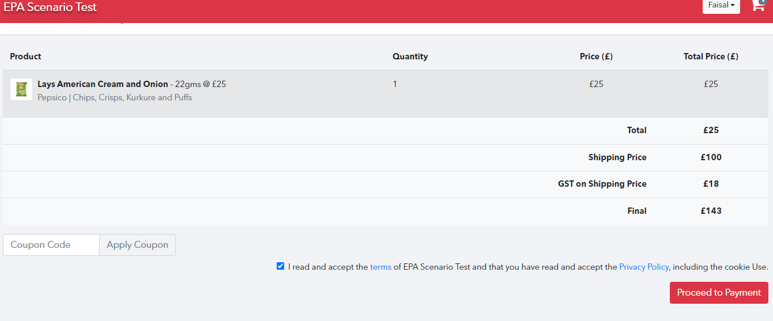
User Story 2:
As a registered user, I want the checkout process to be straightforward without requiring unnecessary information.
Acceptance Criteria:
- The checkout process should allow me to complete a purchase without creating an account.
  - It doesn’t let me complete a purchase as a guest when I click Proceed to checkout it takes me to login page – We had changed that user need to login
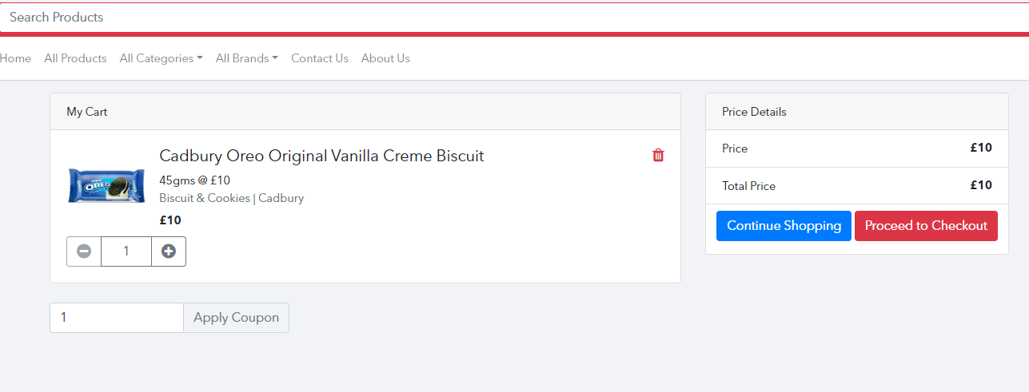
- Only essential information (shipping address, payment details) should be required during the guest checkout.
  - Shipping address is required but nothing about payment details –
Added option to add card details
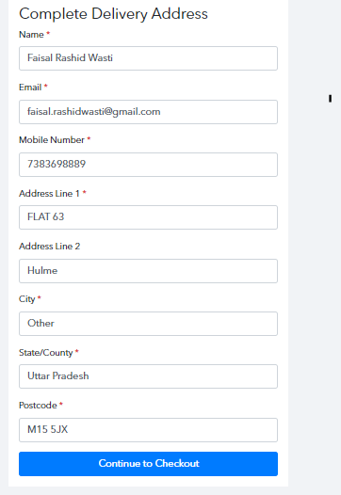
User Story 3:
As a customer, I want to receive real-time updates on the status of my order during the checkout process.
Acceptance Criteria:
- The system should provide real-time updates on the order processing status.
  - Did not see any real time updates. – admin can send after order placed, due to no payment gateway added. no order could placed
- I should receive confirmation emails with order details and tracking information.
  - Didn’t receive anything – order not confirmed as no payment made

Task List:
- 1 Review User Stories and Acceptance Criteria
Task: Examine the provided user stories and acceptance criteria for the checkout process. Identify any gaps, ambiguities, or areas requiring clarification.
(K4, K11, K6, B4 - Addresses the need for traceability, the role of static testing techniques, accuracy in documentation, and logical thinking in decision-making)
  - Can be done (all info provided)
- 2 Design Test Cases
Task: Create test cases using equivalence partitioning, boundary value analysis, and decision table testing for the checkout process. Analyse test objectives and requirements to define test scope and coverage criteria.
(S1, S2, B5 - Applies static test techniques, Black Box test techniques, and analytical skills)
  - Can be done on word processor. Analyse test objectives and requirements to define scope and coverage criteria is this provided or is this something that is created from test cases? Is this acceptance criteria in user stories??
- 3 Apply Static Testing Techniques
Task: Use static testing techniques to review the requirements for the checkout process. Look for potential issues and ensure clarity.
(K11, K6 - Addresses the role of static testing techniques and the importance of accurate documentation)
  - Can be done (User should know the static test techniques)
- 4 Execute Tests and Document Defects
Task: Perform tests on the e-commerce website checkout system. Document test results and trace any defects found back to the respective test cases.
(K2, K4, K6, S1 - Addresses the difference between error, defect, and failure, the need for traceability, accuracy in documentation, and applies static test techniques)
  - Can be done and defect can be logged on tool
- 5 Analyse Metrics and Evaluate Exit Criteria
Task: Analyse testing metrics and evaluate whether the exit criteria have been met. Provide recommendations based on the analysis.
(K16 - Addresses typical metrics used to support monitoring and control of testing)
  - How am I suppose to analyse testing metrics and evaluate. Do I have to create the testing metrics or will it be provided – Yes, learner have to create test metrics
- 6 Explain Testing Approach Difference (Agile vs. Sequential)
Task: Clearly explain the differences in testing approaches between agile and sequential lifecycles.
(S7 - Adapts and applies testing activities according to industry standard development methodologies)
  - Can be done
- 7 Evaluate Quality Risks and Make Recommendations
Task: Assess quality risks based on test results. Provide recommendations for addressing identified risks.
(K14, B4 - Addresses the role of software testing within the context of project and product risk reduction and applies logical thinking in decision-making)
  - Can be done
- 8 Exploratory Testing Session
Task: Conduct an exploratory testing session on a specific aspect of the checkout process. Identify any issues that might not be covered by scripted test cases. Analyse test objectives and requirements to define test scope and coverage criteria.
(S1, S3, B5 - Applies static test techniques, analytical skills, and adapts testing activities)
  - Can be done
- 9 Performance Testing
Task: Evaluate the performance of the checkout process. Simulate multiple users checking out simultaneously to identify any performance bottlenecks.
(S7, K16: Adapts and applies testing activities according to industry standard development methodologies and addresses typical metrics used for testing control)
  - Can be done
- 10 Security Testing
Task: Assess the security aspects of the checkout process. Check for vulnerabilities such as input validation, secure data transmission, and protection against common security threats.
(S1, B5 - Applies static test techniques and analytical skills)
  - Can be done
- 11 Accessibility Testing
Task: Evaluate the accessibility of the checkout process. Ensure that the website is usable by individuals with disabilities and complies with accessibility standards.
(S1, B5, S3 - Applies static test techniques, analytical skills, and analyses test objectives for accessibility)
  - Can be done
- 12 Regression Testing
Task: Perform regression testing to ensure that new changes to the checkout process do not introduce defects in existing functionalities.
(S1, S7 - Applies static test techniques and adapts testing activities according to industry standard development methodologies)
  - Can be done
- 13 Collaboration with Developers
Task: Write up an example of when you collaborated with developers to understand how defects are prioritised and fixed. Explain how you ensured you communicate effectively with the development team.
(S7, B4 - Adapts and applies testing activities according to industry standard development methodologies and applies logical thinking in decision-making)
  - Can be done
- 14 Documentation Improvement
Task: Propose improvements to the existing documentation for the checkout process. Pay attention to detail and communicate effectively.
(K6, B4, K3- Addresses the importance of accuracy and clear documentation of software tests and defects, applies logical thinking in decision-making, and considers the impact of context on the test process)
  - Can be done what do you mean by documentation is it user stories?
- 15 Tool Familiarity
Task: Write about your familiarity testing tools or automation frameworks. Explain how you use these tools effectively in the testing process.
(S7- Adapts and applies testing activities according to industry standard development methodologies)
  - Can be done

SCENARIO TWO
Why Twice & scenario summary heading should be bold & for word processor please specify that tool is down below to be used. Remove email and password and give link like given in scenario tool.
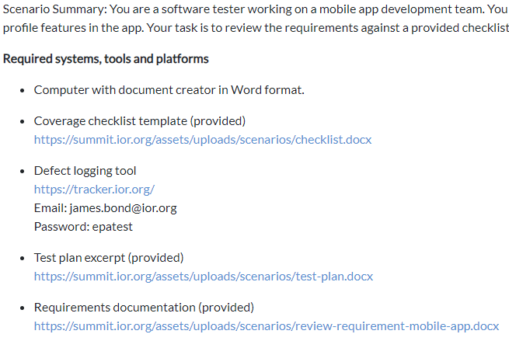
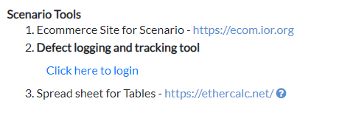
All Docs should be in pdf format not .docx..

Tasks:
- Review the provided requirements for completeness, clarity, testability, and consistency.
(K3, S1, B5)
  - Can be done
- Use the provided coverage checklist to analyse if the requirements sufficiently cover the intended functionality.
(K3, S3, B5)
  - Can be done
- Identify any defects in the requirements based on non-compliance with the checklist criteria.
(K2, S2, B4)
  - Can be done
- Determine if the requirements contain sufficient information to derive test cases. Document any gaps.
(K4, S3, B5)
  - Can be done
- Evaluate whether the requirements mitigate the risks called out in the provided test plan excerpt. Identify any missing risk coverage.
  - Can be done

SCENARIO THREE
Why twice & scenario summary heading should be bold
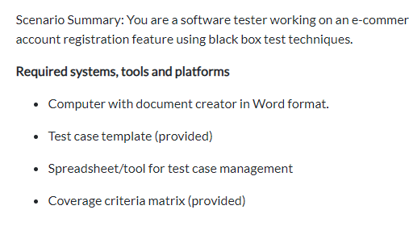
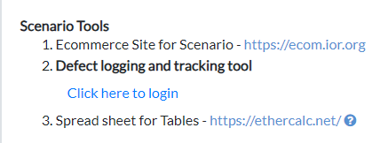

Tasks:
- Review the provided requirements and specifications for the registration feature.
(K3, B5)
  - Can’t be done no docs are provided
- Identify suitable test techniques that could be applied based on the requirements. Select boundary value analysis and equivalence partitioning techniques.
(K14, S2, B5)
  - Can’t be done no docs are provided
- Analyse the expected input fields/parameters for account registration. Identify partitions for valid and invalid equivalence classes.
(S2, B5)
  - Can’t be done no docs are provided
- Determine boundary values at the edges of the equivalence partitions.
(S2, B5)
  - Can’t be done no docs are provided
- Design test cases to cover both the equivalence partitions and boundary values. Document the test cases using a provided template.
(K4, S2, B4)
  - Can’t be done no docs are provided
- Review your test cases against the given coverage criteria. Identify any gaps.
(K3, S3, B5)
  - Can’t be done no docs are provided

GENERAL INFORMATION

- I’ve submitted all tasks and now I can go back and login to tracking tool and log any defects I want to even though the task has been submitted – I can look to create three different project for different scenario and disable access after they submit – I will check if it is possible to disable.
- Does any testing tool need to be provided? They can use like selenium or testlinks etc
- Need a computer with pdf reader yes, it is by default with google chrome
- Required systems, tools, platforms should only be once not twice like (Required systems, tools, platforms and then below scenario tools)
- Please specify to use the word processor that is below.
- Word Processor should be a proper one because all the tasks will be answered there. – this is ok
- All tasks should have their own tools currently if spreadsheet is not required it is still in scenario tools section. This can be used in any scenario if they require.
- Also specify if you use the excel file save & download it and then upload it into summit in the section of that scenario. – it is already there
- Also please leave minor defect in all scenarios for apprentice to find otherwise if it’s all perfect there is nothing for apprentice to find and that could make it really easy.
- Layout of all scenarios should be same currently the layout of all scenarios are different.
- Same tracking tool opened for all scenarios how will it be differentiated when submitted for different tasks? I can look to create three different project for different scenario and disable access after they submit – I will check if it is possible to disable.
- Tell them to download the output of tracking tool and upload it.
- Can I create different excel sheets for different tasks? Yes
- When creating an account on Ecommerce website an email gets sent out below: This is fine
