**Summit AO Development Oct 2023**

1. On the qualifications screen:  
   a) Add the reg fee too  
   b) On the right where the buttons are, have one button showing the number of learners on that qualification.

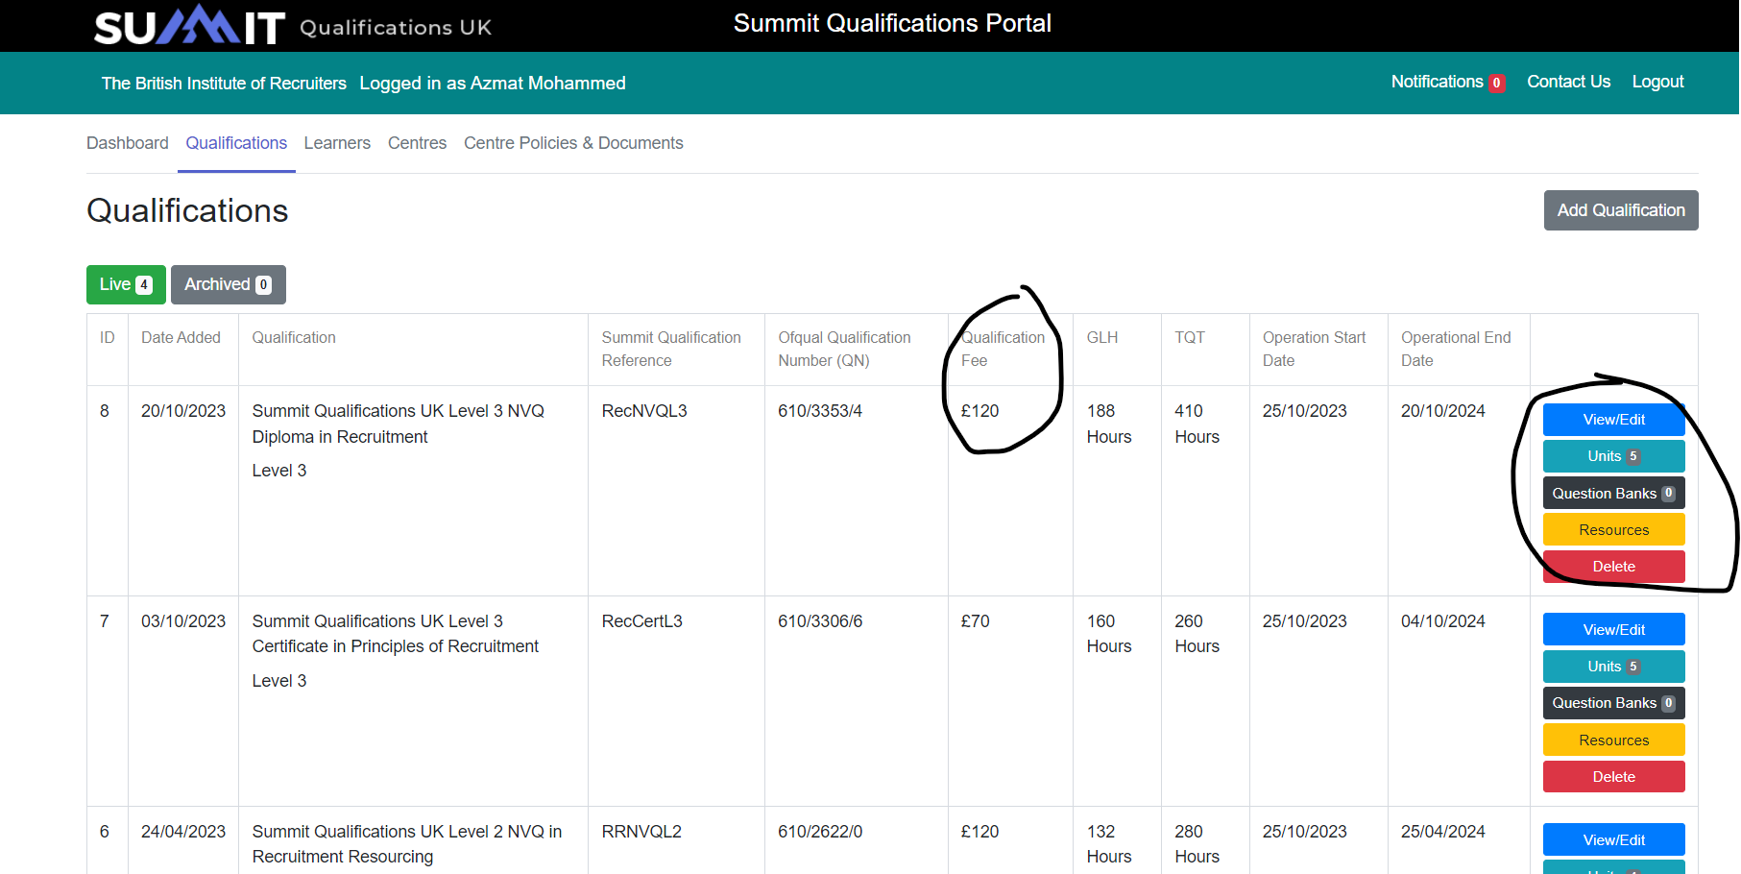

1. Log in as a centre and set the filters to only show preselected what is available for the centre to see:  
   A screenshot of a computer

   Description automatically generated
2. Log in as a centre - Learner record shows a status. I think we should make this automatic, not manually edited by the centre. When they add a learner, they are ‘On Programme’. They can withdraw and start their assessment but Summit needs to auto amend the status like we do in EPA.
3. Log in as a centre – Qualifications  
   There should be a list of qualifications the centre has been approved (by Summit) to deliver and a list of the other qualifications we offer that they are not approved to deliver. If they want to deliver a qualification, we they need to apply to us via the portal by selecting the qual and filling in a qualification approval form (like the IEPA form) and we need to approve it.   
     
   A screenshot of a computer

   Description automatically generated

1. Billing Xero integration  
   a) We need a way to bill for every learner registration when the centre adds a learner.  
   b) We need a way to bill a company that applies to be a Summit centre using the centre application form.  
   c) We need a way top bill people for the qualification fee when they are ready to take the assessment.
2. We need an announcement tool to message a centre (all members of it), learners on a certain qual, or a specific single person etc like the EPA side. Same tool.
3. Learners need login to upload portfolios, so learners need logins.
4. Add the same reasonable adjustment system.
5. Learners and centres need to see results – status changes automatically when results confirmed.
6. A way for a register to withdraw a learner with a simple pop-up form. We don’t need to approve, its done when they submit. Needs to a tab for withdrawn learners.