# 

# **Assessors Declaration of Interests for compliance with External Quality Assurance**

**Compliance with Conflicts of Interests Policy**Assessors undertake to comply with The British Institute of Recruiters Conflicts of Interests Policy.

**Suitability of Assessors**

Assessors should hold the required Qualifications, Knowledge, Skills and Behaviours laid out in assessment plans they will assess and would be considered unsuitable if they have:

(a) any criminal convictions held by him or her,

(b) any finding by a court or any professional, regulatory, or government body that he or she has breached a provision of any legislation or any regulatory obligation to which he or she is subject,

- save for minor driving offences

(c) any proceedings in bankruptcy or any individual financial arrangement to which he or she is or has been subject,

(d) any disqualification from holding the directorship of a company or from public office, or

(e) any finding of malpractice or maladministration, in relation to assessment or related activities to which he or she is or has been subject.

**Declaration**

As an Assessor I agree to comply with the requirements as set out above and will advise The British Institute of Recruiters should there be any change as to my suitability at any time:

**Name**: Clare Chambers

(Print)

**Signed: 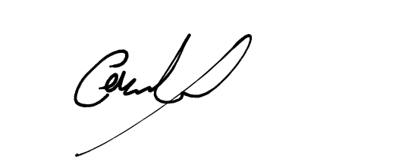 Dated: 17/09/21**